Grove - SPDT Relay(30A)

|  |
| --- |
| **Contents**   [[hide](http://www.seeedstudio.com/wiki/Grove_-_SPDT_Relay(30A))]   * [1 Introduction](http://www.seeedstudio.com/wiki/Grove_-_SPDT_Relay(30A)#Introduction) * [2 Feature](http://www.seeedstudio.com/wiki/Grove_-_SPDT_Relay(30A)#Feature) * [3 Specification](http://www.seeedstudio.com/wiki/Grove_-_SPDT_Relay(30A)#Specification) * [4 Usage](http://www.seeedstudio.com/wiki/Grove_-_SPDT_Relay(30A)#Usage) * [5 Resource](http://www.seeedstudio.com/wiki/Grove_-_SPDT_Relay(30A)#Resource) * [6 Support](http://www.seeedstudio.com/wiki/Grove_-_SPDT_Relay(30A)#Support) |

Introduction

The SPDT Relay(30A) is a high quality Single Pole Double Throw Relay(SPDT).The Relay consist of a coil, 1 common terminal, 1 normally closed terminal, and one normally open terminal. When the coil of the relay is at rest (not energized), the common terminal and the normally closed terminal have continuity. When the coil is energized, the common terminal and the normally open terminal have continuity.This relay's coil is rated up to 5V and the contact is rated up to 30A (@250VAC, 30VDC). Use it to control high current devices.

Feature

* High Switching Current
* SPDT Relay
* normally closed relay

Specification

|  |  |  |  |  |
| --- | --- | --- | --- | --- |
| **Item** | **Min** | **Typical** | **Max** | **Unit** |
| **working Voltage** | 4.75 | 5.0 | 5.25 | VDC |
| **Current** | 185 | | | mA |
| **Pull-In Voltage(Max)** | 3.75 | | | VDC |
| **Operation Time(Max)** | 15 | | | ms |
| **Release Time(Max)** | 10 | | | ms |
| **Operating Ambient Temperature** | -25 | - | 70 | °C |

Usage

Why do we want to use a relay and do we really need to? Anytime you want to switch on/off a device which draws more current or works with a high voltage you'll need to use a relay. that is , the relay is "a high voltage or current switch controlled by low voltage". The coil of an SPDT relay that we most commonly use draws very little current (the [Grove - relay](http://www.seeedstudio.com/wiki/Grove_-_Relay) supports 10A ). Now, with this 30A relay, you can control much more high-current switch devices such as headlights, parking lights, horns, etc.

The SPDT Relay internal structure:  
[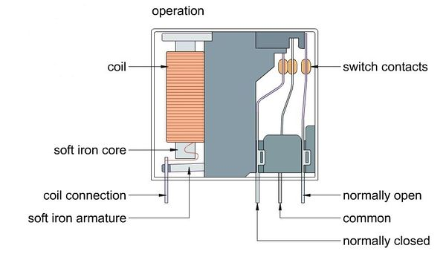](http://www.seeedstudio.com/wiki/File:Relay_Struction.jpg)  
You may observe the common terminal and the normally closed terminal have continuity When the coil of the relay is at rest.

But when the coil is energized, The common terminal and the normally open terminal have continuity.

Hardware Installation can refer to the below picture:

[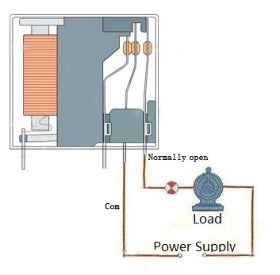](http://www.seeedstudio.com/wiki/File:SPDT_Relay.jpg)

The coding of control this relay is same as the [Grove-Relay](http://www.seeedstudio.com/wiki/Grove_-_Relay).  
Good luck controlling your air-condition or washing machine, with Arduino and , and the Grove - SPDT Relay(30A).